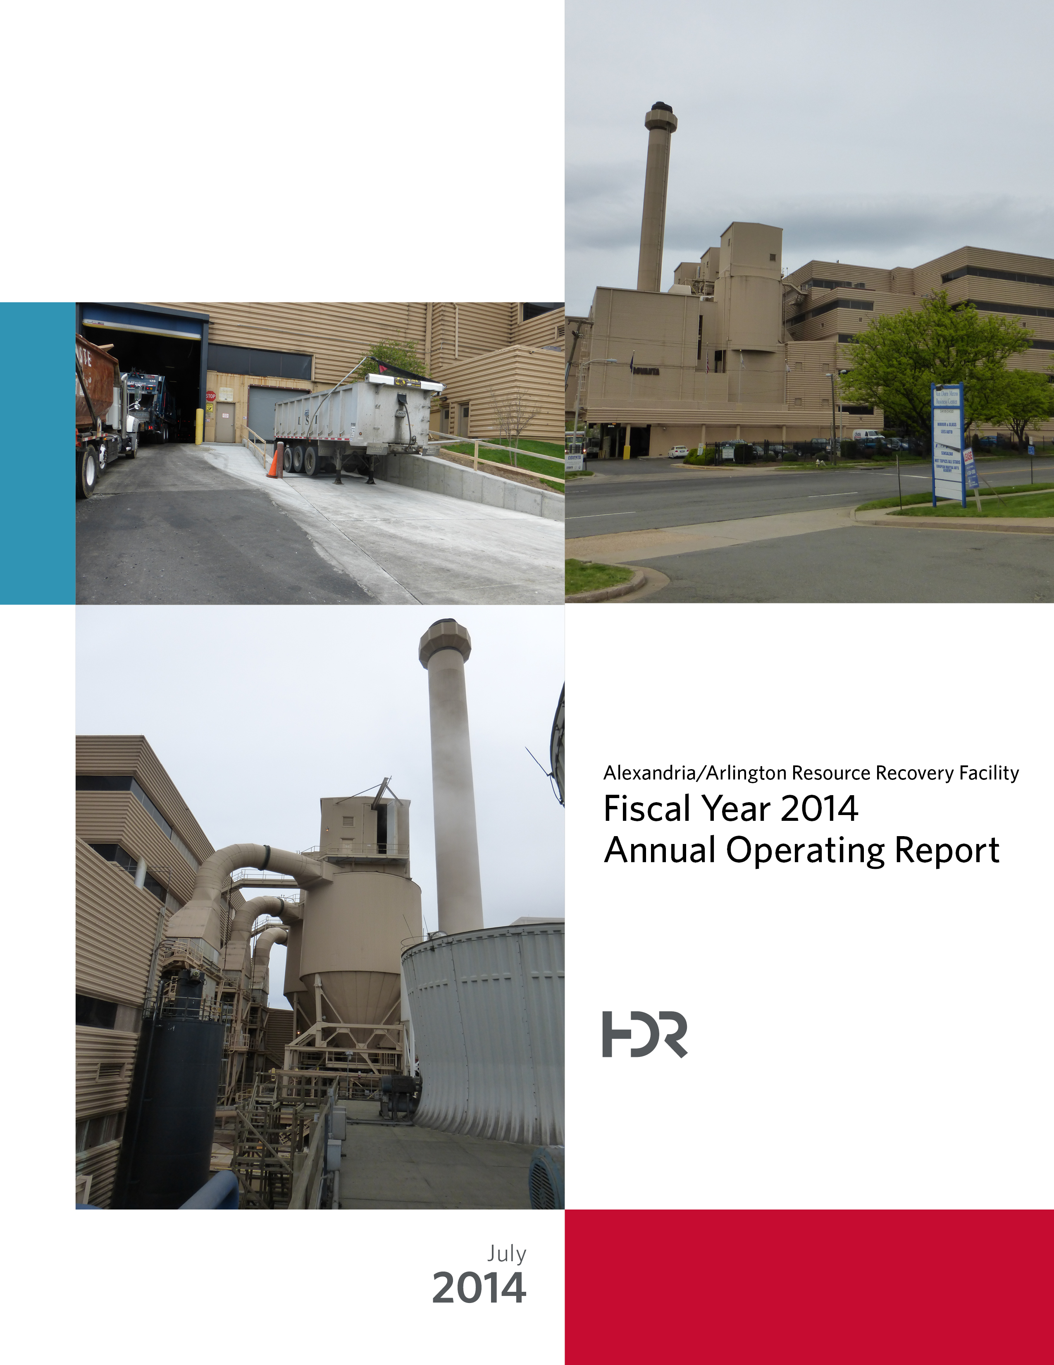

Table of Contents

Section No. Page No.

1.0 Purpose of Report 4

2.0 Executive Summary 4

3.0 Facility Inspection and Records Review 6

4.0 Facility Performance 8

4.1 Utility and Reagent Consumptions 22

4.2 Safety 23

5.0 Facility Maintenance 24

5.1 Availability 24

5.2 Downtime Summary 25

5.3 New Loading Dock Construction 27

5.4 Facility Housekeeping 27

6.0 Environmental 29

6.1 Nitrogen Oxide Emissions 29

6.2 Sulfur Dioxide Emissions 29

6.3 Carbon Monoxide Emissions 29

6.4 Opacity 30

6.5 Daily Emissions Data 30

6.6 2014 Annual Stack Testing 30

6.7 Ash System Compliance 33

APPENDIX A FACILITY CEMS DATA 35

APPENDIX B PHOTOS 39

List of Tables

Table No. Page No.

Table 1: Summary of Audit Report Deficiencies 7

Table 2: Quarterly Performance Summaries 15

Table 3: Waste Delivery Classification 16

Table 4: Facility Utility and Reagent Consumptions 22

Table 5: Quarterly Facility Unit Availabilities 25

Table 6: Boiler Downtime – Q4FY14 26

Table 7: Turbine Generator Downtime – Q4FY14 26

Table 8: Facility Housekeeping Ratings – May 2014 28

Table 9: Quarterly Environmental Excursions 29

Table 10: Stack Test Results through 2014 32

Table 11: Comparison of Statistical Results and Regulatory Thresholds for Metal Analytes 33

Table 12: Unit #1 Monthly Summary for Reportable Emissions Data 36

Table 13: Unit #2 Monthly Summary for Reportable Emissions Data 37

Table 14: Unit #3 Monthly Summary for Reportable Emissions Data 38

List of Charts

Chart No. Page No.

Chart 1: Tons of Waste Processed 8

Chart 2: Tons of Ash Produced per Ton of Waste Processed 9

Chart 3: Ferrous Recovery Rate 10

Chart 4: Steam Production 11

Chart 5: 12-Month Rolling Steam Production 12

Chart 6: Steam Production Rate 13

Chart 7: Calculated Waste Heating Value 14

Chart 8: Cumulative Total Waste Delivery 17

Chart 9: Gross Electrical Generation 17

Chart 10: Gross Conversion Rate 18

Chart 11: Net Conversion Rate 19

Chart 12: Net Conversion Rate 20

Chart 13: Gross Turbine Generator Conversion Rate 20

Chart 14: Net Turbine Generator Conversion Rate 22

Chart 15: Stack Test Results through 2014 31

Chart 16: Ash Toxicity Characteristic Leaching Procedure (TCLP) Results 33

Chart 17: Quarterly Ash Test Results 34

List of Figures

Figure No. Page No.

Figure 1: Fire hose not mounted properly at SDA No. 3 Penthouse Access Door - New Deficiency 40

Figure 2: Personal Protective Equipment locker in APC MCC Electrical Room Empty – New Deficiency 40

Figure 3: Unused tarp laying over cable trays at Slaker Room No. 1 40

Figure 4: Pothole at Tipping Floor Exit Driveway 40

Figure 5: Concrete to roadway drain at truck entrance damaged – exposing reinforcing bar 40

Figure 6: Cooling Tower Deck from SDA Penthouse 40

Figure 7: Deaerator 41

Figure 8: Auxiliary Burner 41

Figure 9: Turbine Generator Enclosure – New Paint Job on Turbine Generator No. 1 41

Figure 10: New Screw Conveyor Troughs 41

Figure 11: Dolomitic Lime Silo 41

Figure 12: SDA No. 2 Double Dump Valve 41

Figure 13: Lime Slaker Enclosure 42

Figure 14: Lime Slurry Pump Enclosure 42

Figure 15: Ash Load-Out Area 42

Figure 16: Ammonia Storage Tank 42

Figure 17: New Loading Dock – Construction complete with the exception of permanent safety railings 42

Figure 18: New Loading Dock – Alternate View 42

Figure 19: New Tipping Floor Signs – (Deficiency Item No. 4 – Complete) 43

Figure 20: White Goods Roll-Off 43

Figure 21: Scale House and Scale Area 43

Figure 22: Citizen’s Drop-off Roll-off 43

Figure 23: Main Vibratory Ash Conveyor 43

Figure 24: Steam Coil Air Heater 43

**Definition of Abbreviations & Acronyms**

|  |  |
| --- | --- |
| Abbreviation/Acronym | Definition |
| APC | Air Pollution Control |
| Apr | April |
| Aug | August |
| Avg | Average |
| Btu | British thermal unit |
| CAAI | Covanta Alexandria Arlington, Inc. |
| CEMS | Continuous Emissions Monitoring System |
| CO | Carbon Monoxide |
| Dec | December |
| Feb | February |
| FMG | Facility Monitoring Group |
| FY | Fiscal Year |
| gal | Gallon |
| GAT | Guaranteed Annual Tonnage |
| HCl | Hydrochloric (Hydrogen Chlorides) |
| HDR | HDR Engineering Inc |
| ID | Induced Draft |
| Jan | January |
| Jul | July |
| Jun | June |
| klbs | Kilo-pounds (1,000 lbs) |
| kWhr | Kilowatt hours (1,000 watt-hours) |
| lbs | Pounds |
| LOA | Letter of Agreement |
| Mar | March |
| Max | Maximum |
| May | May |
| Min | Minimum |
| MSW | Municipal Solid Waste |
| MWhr | Megawatt hours |
| No | Number |
| NOV | Notice of Violation |
| Nov | November |
| NOx | Nitrogen Oxide |
| Oct | October |
| OSHA | Occupational Safety and Health Administration |
| PDS | Potomac Disposal Services |
| ppm | Parts per million |
| ppmdv | Parts per million dry volume |
| PSD | Prevention of Significant Deterioration |
| Q1 | First Quarter |
| Q2 | Second Quarter |
| Q3 | Third Quarter |
| Q4 | Fourth Quarter |
| RE | Reportable Exempt |
| RNE | Reportable Non-Exempt |
| SDA | Spray Dryer Absorber |
| Sep | September |
| SO2 | Sulfur Dioxide |
| TCLP | Toxicity Characteristic Leaching Procedure |
| VADEQ | Virginia Department of Environmental Quality |
| WL | Warning Letter |
| yr | Year |
| YTD | Year to date |

Alexandria/Arlington Waste-to-Energy Facility

Fiscal Year 2014 Operating Report

# Purpose of Report

HDR Engineering, Inc. (HDR) was given authorization by the Facility Monitoring Group (FMG) to conduct quarterly inspections and provide quarterly monitoring reports regarding the operation and maintenance of the Covanta Alexandria/Arlington Waste-to-Energy Facility (Facility) for the 2014 calendar year. This report is prepared for the fourth quarter of the 2014 fiscal year and summarizes Facility operations between April 1, 2014 and June 30, 2014, as well as the entire fiscal year. This report identifies the fiscal year beginning on July 1, 2013 as FY14 and the quarter beginning on April 1, 2014 as Q4FY14.

This report is based upon the experience HDR has in the waste-to-energy industry, upon site observation visits and previous reports provided by HDR, and upon data provided by Covanta Alexandria / Arlington, Inc. (CAAI), the Facility owner and operator.

# Executive Summary

CAAI operated the Facility in an acceptable manner and in accordance with established waste-to-energy industry practices during Q4FY14. The operation of the Facility, maintenance, safety, and overall cleanliness continue to be above average. Environmental performance was excellent with no reportable environmental excursions throughout the quarter.

During Q4FY14, the Facility experienced four (4) instances of unscheduled downtime for the boilers totaling 70.6 hours, and no unscheduled downtime for the turbine generators. No scheduled maintenance was conducted during the quarter. The boilers experienced five (5) instances of standby time totaling 95.3 hours, and the turbine generators experienced two (2) instances of standby time totaling 2.5 hours during the quarter. A detailed listing of downtime is provided in Section 5.2 of this report.

Average waste processed during the quarter was 1,041.0 tons per day, or 106.8% of nominal facility capacity. Waste deliveries averaged 1,043.8 tons per day, which is 0.3% higher than the burn rate. The capacity utilization of 106.8% compares favorably to industry averages, which are generally in the 88% to 92% range.

On an annual basis, average waste processed was 956.5 tons per day, or 98.1% of nominal facility capacity of 975 tons per day. Waste deliveries averaged 958.8 tons per day, which is 0.2% more than the annual burn rate. The annual capacity utilization of 98.1% compares very favorably to industry averages.

Performance trends for various measurements are presented in Section 4. In general, the Facility continues to demonstrate reasonable consistency in month to month performance throughout the most recent three year period tracked for detailed comparisons.

During the quarter, MSW processed decreased 1.0% from the corresponding quarter in FY13; steam production decreased 2.5%, and electricity generated (gross) decreased 4.4% from the corresponding quarter in FY13. The decrease in steam generation was largely attributable to the decrease (3.0%) in the calculated average waste heating value, as well as more (17.8 additional hours) unscheduled and standby downtime experienced by the boilers. The decrease in gross electrical generation in Q4FY14 as compared to Q4FY13 is attributable to the decrease in steam production.

During FY14, MSW processed increased 0.4% from FY13; steam production decreased 2.9%, and electricity generated (gross) decreased 2.9% compared to FY13. The decrease in steam generation was attributable to the decrease (4.4%) in the calculated average waste heating value, as well as more (291.8 additional hours) scheduled, unscheduled, and standby downtime experienced by the boilers. The decrease in gross electrical generation in FY14 as compared to FY13 is attributable to the decrease in steam production, as well as more (238.4 additional hours) scheduled, unscheduled, and standby downtime experienced by the turbine generators.

# Facility Inspection and Records Review

In May 2014, HDR met with the Facility management and other plant personnel to discuss Facility operations and maintenance, acquire Facility data and reports, perform an independent visual inspection of the operating Facility, photograph areas of interest, and perform a review of recent Facility activity. This visit was coordinated with the scheduled FMG Meeting. At the time of the visit, HDR reviewed CAAI records, discussed performance issues with CAAI staff, and provided a verbal report and performance statistics. HDR maintains a running tabulation of the status of corrective actions and plant performance trends. CAAI provides the following documents for each month:

* Facility Monthly Operating Reports
* Monthly Continuous Emissions Monitoring System (CEMS) Reports

Table 1 summarizes maintenance, repair, and plant condition issues reported during this and prior audit reporting periods. An “A” indicates an issue of the highest priority and worthy of immediate attention. Such items are usually safety or operability issues. A “B” indicates that the issue needs to be dealt with as quickly as possible, but is not urgent. These items will usually result in a process improvement or will help avoid future “urgent” issues. A “C” indicates that the issue should be dealt with at the earliest convenience, but is not a priority issue. This category might include issues related to aesthetics, non-urgent maintenance, or housekeeping improvements which are not safety related.

Table 1: Summary of Audit Report Deficiencies

*A is highest priority & demands immediate attention: B needs attention, but is not urgent; C can be addressed at earliest opportunity & is not urgent.

| Item No. | Audit Report Deficiencies | Issue Reported | Priority* | Resolution/Status | Date Resolved | Open / Closed |
| --- | --- | --- | --- | --- | --- | --- |
| 1 | Spider cracking at scale entry area | July 2010 | C | Repair |  | Open |
| 2 | Pothole at truck entry roadway | May 2012 | C | Repair |  | Open |
| 3 | Fire extinguisher certification throughout the Facility expired - Typical of All | February 2014 | A | Inspect and re-certify fire extinguishers throughout the Facility | May 2014 | Closed |
| 4 | Danger sign on column at pit edge damaged | February 2014 | A | Replace danger signs at Tipping Floor Pit Edge | May 2014 | Closed |
| 5 | Fire hose not mounted properly at SDA No. 3 Penthouse Access Door - See Figure 1 (Appendix B) | May 2014 | A | Properly stow fire hose |  | Open |
| 6 | Personal Protective Equipment locker in APC MCC Electrical Room Empty – See Figure 2 (Appendix B) | May 2014 | A | Stock PPE Locker with proper equipment |  | Open |
| 7 | Unused tarp laying over cable trays at Slaker Room No. 1 – See Figure 3 (Appendix B) | May 2014 | A | Remove tarp |  | Open |
| 8 | Pothole at Tipping Floor Exit Driveway– See Figure 4 (Appendix B) | May 2014 | C | Repair pothole |  | Open |
| 9 | Concrete to roadway drain at truck entrance damaged – exposing reinforcing bar – See Figure 5 (Appendix B) | May 2014 | C | Repair damaged concrete |  | Open |

# Facility Performance

Monthly operating data provided by CAAI indicates that 94,734 tons of MSW were processed during Q4FY14, and a total of 94,988 tons of MSW including 514 tons of Special Handling Waste were received. Total ash production during the quarter was 19,035 tons, which represents 20.1% of the waste processed. The average uncorrected steam production rate for Q4FY14 was 2.9 tonssteam/tonwaste, which is 1.5% less than the corresponding quarter in FY13. The decrease in this metric is attributable to the decrease (3.0%) in the calculated average waste heating value that was experienced during the quarter, as compared to the corresponding quarter in FY13.

On an annual basis, 349,118 tons of MSW were processed during FY14, and a total of 349,946 tons of MSW and 3,549 tons of Special Handling Waste were received. Total ash production during FY14 was 72,071 tons, which represents 20.6% of the waste processed. The average uncorrected steam production rate for FY14 was 3.0 tonssteam/tonwaste, and 3.3% lower than the corresponding period last year. The decrease in this metric is attributable to the decrease (4.4%) in the calculated average waste heating value that was experienced in FY14, as compared to FY13.

Chart 1: Tons of Waste Processed

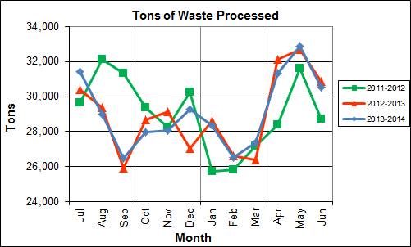

Chart 1 illustrates that Q4FY14 waste processed was slightly lower (1.0%) than the corresponding quarter, Q4FY13.

CAAI reported that 447 tipping floor/MSW internal inspections were conducted during the quarter and CAAI issued one (1) notice of violation (NOV) in May for jumping in line and leaving trash on the exit ramp. No NOV’s were issued in April or June 2014.

Chart 2: Tons of Ash Produced per Ton of Waste Processed

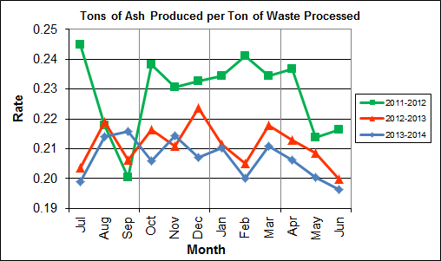

Chart 2 illustrates that ash production rates in Q4FY14 are lower (3.0%) at 20.1% of processed waste, compared to the corresponding quarter in FY13 when the ash production rate was 20.7% of processed waste. The decrease in the quarterly ash is attributable to the significant increase (14.2%) in ferrous metal recovery.

The annual ash production rate for FY14 was lower (2.3%) at 20.6% of processed waste, compared to FY13 when the annual ash production rate was 21.1% of processed waste. The decrease in ash production (20.0% - 21.0% Range), which began in May 2012 is attributed to the installation of the “semi-dry” ash discharger spray system, and represents less moisture in the ash residue shipped to disposal. Another contributing factor is the aforementioned increase in ferrous metal recovery. CAAI installed a new ferrous magnet shell during the latter part of the fall outage season in December 2013 and ferrous metal recovery has been significantly higher in recent months as a result.

Chart 3: Ferrous Recovery Rate

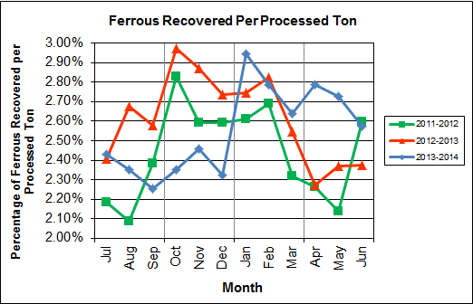

Chart 3 depicts the monthly ferrous metal recovery rate as a percentage of processed MSW tonnage. In Q4FY14, 2,556 tons of ferrous metals were recovered, which is 14.2% higher than the corresponding quarter in FY13 and equivalent to 2.7% of processed waste. The increase in ferrous metal recovery is attributable to the recently installed ferrous magnet shell, which was replaced during an outage in December 2013.

In FY14, 8,922 tons of ferrous metals were recovered, which is 1.6% lower than FY13 and equivalent to 2.6% of processed waste. As depicted in Chart 3, the second half of FY14 had an increased ferrous recovery rate as a result of the new magnet shell installation, which offset the first half of the year which was lower than the prior two fiscal years.

Chart 4: Steam Production

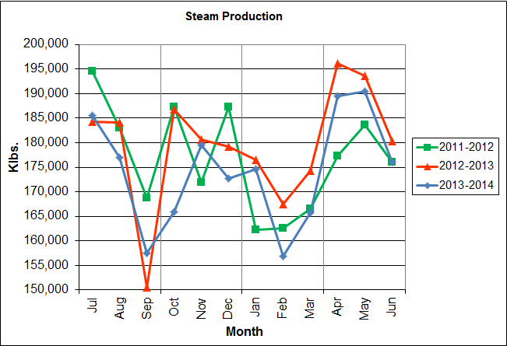

In Chart 4, the total steam production for Q4FY14 was 555,969 klbs., or 2.5% lower than the corresponding quarter in FY13. The decrease in steam production is attributable to the lower (3.0%) calculated average waste heating value during the quarter.

Annual steam production for FY14 was 2,091,123 klbs., or 2.9% lower than FY13 which produced 2,154,201 klbs. The decrease in annual steam production can be attributed to a decrease (4.4%) in waste heating value, as well as an increase in downtime experienced by the boilers in FY14 (1,677.1 total hours) as compared to FY13 (1,385.3 total hours).

Chart 5: 12-Month Rolling Steam Production

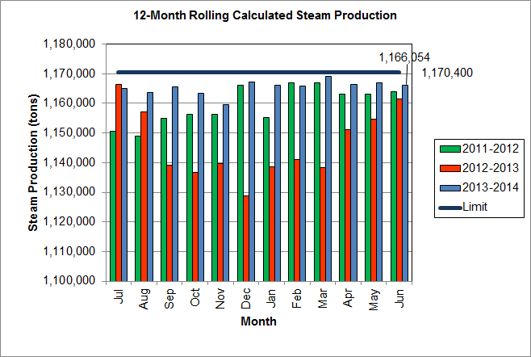

Chart 5 depicts the 12-month rolling steam production total for the period ending in June 2014. According to the Title V permit, the annual steam production for the Facility shall not exceed 1,170,400 tons on the basis of an average value of 3.34 lbs of steam per lb of MSW processed, calculated monthly as the sum of each consecutive 12 month period. The Facility was in compliance with the 12-month rolling steam production total every month in the quarter. The 12-month rolling total for steam production ending in June 2014 was 1,166,054 tons which is 99.6% of the limit.

Chart 6: Steam Production Rate

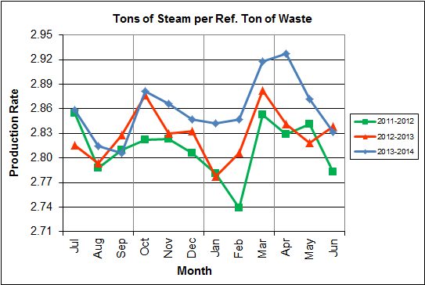

In Chart 6, the conversion of raw waste tonnages into “reference tons” is another way of analyzing steam production, and helps to determine whether changes are related to boiler performance or to fuel issues. “Reference tons” are adjusted to account for the calculated average fuel heating value, so that lower Btu fuel raw tonnages are adjusted upwards and vice versa. In Q4FY14 this metric tracked higher (1.6%), at 2.9 tonssteam/tonref, than the corresponding quarter in FY13.

The annual steam production rate for FY14 was 2.9 tonssteam/tonref, which is higher (1.1%) than FY13. The small magnitude of the year to year and quarter to quarter changes in this parameter is not significant, but rather indicates consistent performance.

**Chart 7: Calculated Waste Heating Value**

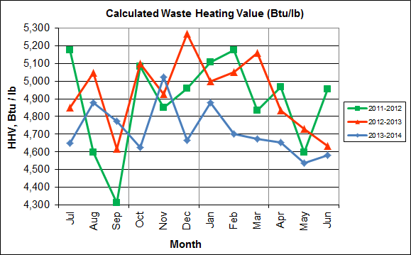

Chart 7 illustrates that Q4FY14 calculated average waste heating value was lower (3.0%) at 4,590 Btu/lb than the corresponding quarter Q4FY13, which averaged 4,733 Btu/lb.

In FY14, the annual average waste heating value was lower (4.4%) at 4,720 Btu/lb than FY13, which averaged 4,935 Btu/lb.

Table 2: Quarterly Performance Summaries

|  |  |  |  |  |  |  |  |  |
| --- | --- | --- | --- | --- | --- | --- | --- | --- |
| Month | | Waste Processed (tons) | Waste Diverted  (tons) | Ash Shipped  (tons) | Special Handling (Supplemental)  (tons) | Ferrous Recovered  (tons) | Steam Produced (klbs) | Net Electrical Generation  (MWhr) |
| **Q4FY12** | **Quarterly Totals** | **88,744** | **0** | **19,705** | **182** | **2,064** | **537,001** | **38,503** |
| April-12 | 28,383 | 0 | 6,721 | 23 | 642 | 177,252 | 12,845 |
| May-12 | 31,623 | 0 | 6,762 | 68 | 676 | 183,629 | 12,961 |
| June-12 | 28,738 | 0 | 6,222 | 91 | 746 | 176,120 | 12,697 |
| **Q4FY13** | **Quarterly Totals** | **95,680** | **0** | **19,826** | **955** | **2,238** | **570,212** | **41,391** |
| April-13 | 32,147 | 0 | 6,844 | 403 | 731 | 196,219 | 14,536 |
| May-13 | 32,682 | 0 | 6,817 | 281 | 775 | 193,668 | 14,186 |
| June-13 | 30,851 | 0 | 6,165 | 271 | 732 | 180,325 | 12,669 |
| **Q4FY14** | **Quarterly Totals** | **94,734** | **0** | **19,035** | **514** | **2,556** | **555,969** | **39,409** |
| April-14 | 31,317 | 0 | 6,454 | 253 | 873 | 189,568 | 13,568 |
| May-14 | 32,873 | 0 | 6,585 | 151 | 897 | 190,394 | 13,515 |
| June-14 | 30,544 | 0 | 5,996 | 110 | 786 | 176,007 | 12,326 |
| **FY14 Totals** | | **349,118** | **0** | **72,071** | **3,549** | **8,922** | **2,099,974** | **143,064** |
| **FY13 Totals** | | **347,790** | **0** | **73,446** | **2,665** | **9,063** | **2,154,201** | **148,366** |
| **FY12 Totals** | | **348,455** | **0** | **79,424** | **336** | **8,474** | **2,121,209** | **149,919** |

Table 2 presents the production data provided to HDR by CAAI for Q4FY14 on both a monthly and quarterly basis. For purposes of comparison, data for Q4FY12 and Q4FY13 are also shown, as well as FY12, FY13 and FY14 totals.

In comparing quarterly totals, the data shows:

* Less waste was processed in Q4FY14 than Q4FY13 and more than Q4FY12
* Less steam was generated in Q4FY14 than Q4FY13 and more than Q4FY12
* Less electricity was generated in Q4FY14 than Q4FY13 and more than Q4FY12
* Less supplemental waste was received in Q4FY14 than Q4FY13 and significantly more than Q4FY12.

Please note that the total steam generation figures presented in Table 2 do not correlate with the annual steam production limit from the Facility Permit; such limits apply on a 12-month rolling average monthly basis, and not a fiscal year basis. It is also worth noting that the quantity of waste processed during Q4FY14 and FY14 continues to be limited by the steam production permit restrictions (refer to Chart 5).

Table 3: Waste Delivery Classification

|  |  |  |  |  |  |  |  |  |  |  |  |  |  |  |  |
| --- | --- | --- | --- | --- | --- | --- | --- | --- | --- | --- | --- | --- | --- | --- | --- |
|  |  | **Jul** | **Aug** | **Sep** | **Oct** | **Nov** | **Dec** | **Jan** | **Feb** | **Mar** | **Apr** | **May** | **Jun** | **Totals** | **% of Total** |
| **FY11** | **Jurisdiction Waste** | 18,201 | 19,320 | 18,100 | 18,244 | 17,812 | 17,394 | 16,316 | 15,212 | 18,279 | 18,596 | 20,355 | 19,382 | 217,213 | 62.20% |
| **Spot Waste tons** | 13,996 | 13,917 | 11,696 | 9,336 | 10,177 | 11,441 | 12,968 | 7,016 | 8,459 | 10,177 | 12,947 | 9,657 | 131,786 | 37.74% |
| **Supplemental Waste** | 8 | 17 | 12 | 13 | 6 | 13 | 14 | 34 | 25 | 29 | 26 | 6 | 203 | 0.06% |
| **MSW Totals** | **32,205** | **33,254** | **29,808** | **27,593** | **27,995** | **28,848** | **29,298** | **22,262** | **26,763** | **28,803** | **33,328** | **29,044** | **349,202** | **100.00%** |
|  |  |  |  |  |  |  |  |  |  |  |  |  |  |  |  |
| **FY12** | **Jurisdiction Waste** | 18,112 | 20,021 | 19,304 | 17,796 | 17,523 | 17,211 | 16,202 | 14,952 | 17,430 | 18,338 | 20,138 | 18,361 | 215,381 | 61.89% |
| **Spot Waste tons** | 8,901 | 13,623 | 13,303 | 9,788 | 11,976 | 11,900 | 10,276 | 10,697 | 10,283 | 10,029 | 11,333 | 10,177 | 132,295 | 38.01% |
| **Supplemental Waste** | 10 | 10 | 34 | 15 | 15 | 21 | 12 | 22 | 15 | 23 | 68 | 91 | 336 | 0.10% |
| **MSW Totals** | **27,023** | **33,654** | **32,641** | **27,599** | **29,514** | **29,132** | **26,490** | **25,672** | **27,729** | **28,390** | **31,539** | **28,629** | **348,012** | **100.00%** |
|  |  |  |  |  |  |  |  |  |  |  |  |  |  |  |  |
| **FY13** | **Jurisdiction Waste** | 19,413 | 18,357 | 16,632 | 17,625( | 18,838 | 16,195 | **-** | **-** | **-** | **-** | **-** | **-** | 107,058 | 30.76% |
| **Spot Waste tons** | 10,516 | 11,326 | 10,610 | 10,317 | 9,330 | 9,558 | **-** | **-** | **-** | **-** | **-** | **-** | 61,656 | 17.72% |
| **City Waste** | **-** | **-** | **-** | **-** | **-** | **-** | 1,683(1) | 1,287 | 1,444 | 2,382 | 2,286 | 1,919 | 11,000 | 3.16% |
| **County Waste** | **-** | **-** | **-** | **-** | **-** | **-** | 2,442(1) | 2,100 | 2,372 | 3,381 | 3,932 | 3,309 | 17,536 | 5.04% |
| **Municipal Solid Waste** | **-** | **-** | **-** | **-** | **-** | **-** | 25,019(1) | 23,637 | 21,661 | 27,066 | 25,794 | 24,930 | 148,107 | 42.56% |
| **Supplemental Waste** | 151 | 11 | 80 | 25 | 234 | 405 | 363 | 365 | 76 | 403 | 281 | 271 | 2,665 | 0.77% |
| **MSW Totals** | **29,928** | **29,683** | **27,241** | **27,942** | **28,167** | **25,753** | **29,507** | **27,388** | **25,552** | **33,231** | **32,293** | **30,429** | **348,022** | **100.00%** |
|  |  |  |  |  |  |  |  |  |  |  |  |  |  |  |  |
| **FY14** | **City Waste** | 2,065 | 1,693 | 1,702 | 1,924 | 1,566 | 1,780 | 1,529 | 1,231 | 1,556 | 2,256 | 2,203 | 1,883 | 21,389 | 6.11% |
| **County Waste** | 3,459 | 3,079 | 2,784 | 3,091 | 2,707 | 2,802 | 2,568 | 1,957 | 2,272 | 3,326 | 3,987 | 3,387 | 35,419 | 10.12% |
| **Municipal Solid Waste** | 26,167 | 23,604 | 22,034 | 23,354 | 21,879 | 25,531 | 23,869 | 22,523 | 23,198 | 25,414 | 27,206 | 24,812 | 289,590 | 82.75% |
| **Supplemental Waste** | 546 | 676 | 248 | 410 | 188 | 268 | 275 | 192 | 231 | 253 | 151 | 110 | 3,548 | 1.01% |
| **MSW Totals** | **32,237** | **29,053** | **26,768** | **28,779** | **26,340** | **30,380** | **28,241** | **25,903** | **27,256** | **31,249** | **33,546** | **30,193** | **349,946** | **100.00%** |
| **Note (1): Beginning January 2013, the method in which waste was classified was modified as compared to prior periods due to change in contractual obligations and plant ownership** | | | | | | | | | | | | | | | |

Chart 8: Cumulative Total Waste Delivery

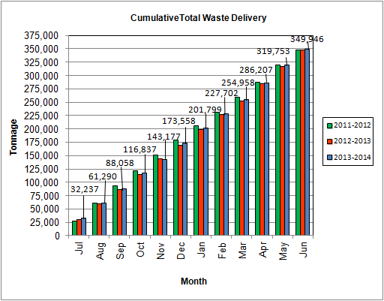

As Depicted in Table 3 and Chart 8, for the period ending in June 2014; cumulative total waste delivery was 0.6% more compared to the same period in FY13.

Chart 9: Gross Electrical Generation

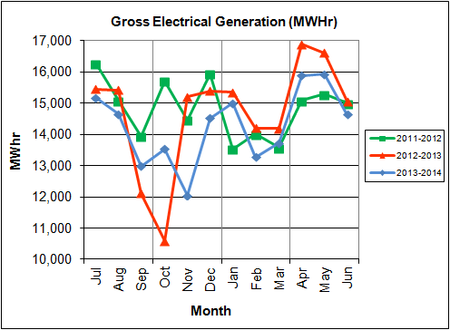

During Q4FY14, the Facility generated 46,444 MWhrs (gross) of electricity compared to Q4FY13 generation of 48,557 MWhrs (gross), a 4.4% decrease. The decrease in gross electrical production is attributable to the decrease (2.5%) in steam production as a result of lower waste heating value and increase boiler downtime.

During FY14, the Facility generated 171,320 MWhrs (gross) of electricity compared to the FY13 generation of 176,467, a 2.9% decrease. The decrease in gross electrical generation for FY14 is attributable to increased turbine generator downtime which totaled 1,677.1 hours (scheduled, unscheduled and standby), as compared to the 1,385.3 hours (scheduled, unscheduled and standby) experienced in FY13. Note that the 3-year low of gross electrical production experienced in October 2012 was due to Turbine Generator No. 1 experiencing 494.5 hours of downtime for scheduled maintenance and again in October 2013 when Turbine Generator No. 2 had a major overhaul. Evidence of the downtime experienced by the Turbine Generators is also apparent in Chart Nos. 10 through 14, including sharp spikes in the trends for the months of October 2012 and 2013 as well as November 2013 when the Overhauls were conducted on Turbine Generator Nos. 1 and 2.

Chart 10: Gross Conversion Rate

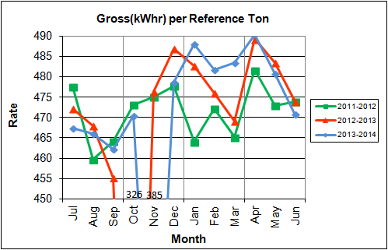

As shown in Chart 10, the average gross electrical generation per reference ton of refuse processed during Q4FY14 was 481 kWhr, which is 0.3% lower than the corresponding quarter in FY13. Since this calculated value uses reference or normalized tonnages of waste, it should cancel the effect of MSW heating value (Btu content) variability.

During FY14, the average gross electrical generation per reference ton of refuse processed was 469 kWhr, which is higher (1.2%) than FY13.

Chart 11: Net Conversion Rate

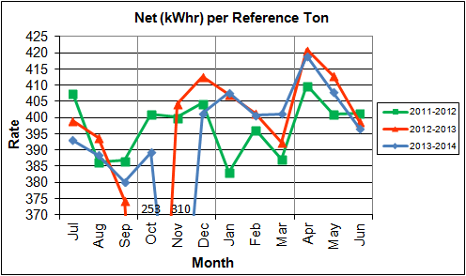

Chart 11 depicts the normalized net power (gross minus in-house usage) generation history. In Q4FY14, the average net electrical generation per reference ton was 408 kWhr, which is 0.8% lower than the corresponding quarter in FY13.

In FY14, the average net electrical generation per reference ton was 391 kWhr, which is 0.5% higher than FY13.

Chart 12: Net Conversion Rate

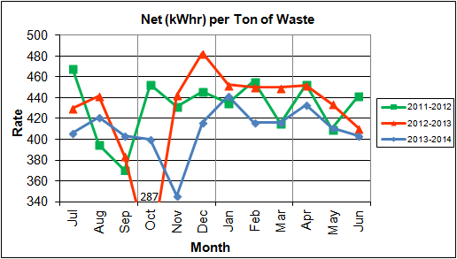

Chart 12 depicts the net power generation per processed ton. The net electrical generation per processed ton in Q4FY14 was 416 kWhr, which is 3.8% lower than the corresponding quarter in FY13.

In FY14, the net electrical generation per processed ton was 410 kWhr which is 4.0% lower than FY13.

Chart 13: Gross Turbine Generator Conversion Rate

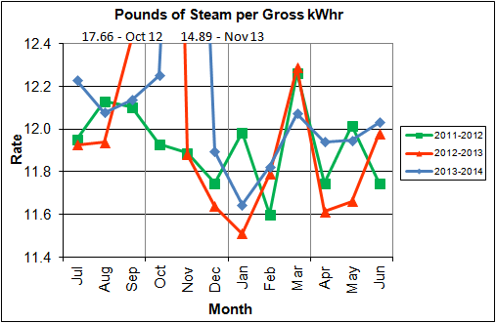

Charts 13 and 14 illustrate the quantities of steam required to generate one kWhr of electricity, gross and net respectively. This measure is a turbine generator performance indicator, where lower steam rates indicate superior performance. For simplification, this calculated rate is based on the average for the two turbine generators. In Q4FY14 the average lbs of steam consumed per gross kWhr was 12.0, which is higher (1.9%) than the corresponding quarter Q4FY13. The average lbs of steam consumed per net kWhr was 14.1, which is higher (2.4%) than the corresponding quarter in FY13. The average steam temperature during the quarter was 681.4° F, which is 2.6% lower than the average steam temperature of the corresponding quarter last year, and 18.6o F lower than design temperature of 700o F.

In FY14, the average lbs of steam consumed per gross kWhr was 12.2, which is identical to FY13. The average lbs of steam consumed per net kWhr in FY14 was 14.6, which is 0.7% higher than FY13. The average steam temperature for FY14 was 681.6o F, which is 1.2% lower than FY13 and 18.4o F lower than the design temperature of 700o F. It is noted that steam consumption per kWhr, both gross and net, are adversely affected by the very high levels associated with the aforementioned Turbine Generator No. 1 major overhaul in September/October 2012, and Turbine Generator No. 2 in November 2013. CAAI reported that during the Turbine Generator No. 2 overhaul, some cracking was observed on the Stage 9 blades of the rotor, and the blading in that row was removed as a precautionary measure. CAAI indicated that a new set of blades will be manufactured and installed during a Turbine Generator No. 2 Outage in 2016. As a result of the blank stage, turbine generator performance (Chart Nos. 13 and 14) didn’t improve to the level which would normally be expected following turbine generator major overhauls.

Chart 14: Net Turbine Generator Conversion Rate

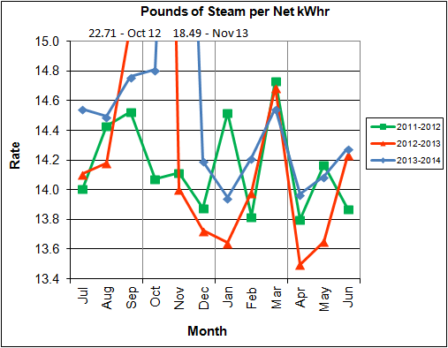

## Utility and Reagent Consumptions

Table 4: Facility Utility and Reagent Consumptions

|  |  |  |  |  |  |  |  |
| --- | --- | --- | --- | --- | --- | --- | --- |
| **Utility** | **Units** | **Q4FY14 Total** | **Q4FY13**  **Total** | **Q4FY14”Per Processed Ton” Consumption** | **Q4FY13”Per Processed Ton” Consumption** | **FY14**  **Total** | **FY13**  **Total** |
| **Purchased Power** | MWhr | 5,409 | 5,467 | 0.06 | 0.06 | 22,724 | 21,925 |
| **Fuel Oil** | Gal. | 13,340 | 13,450 | 0.14 | 0.14 | 54,350 | 50,890 |
| **Boiler Make-up** | Gal. | 2,352,000 | 2,080,000 | 24.83 | 21.74 | 8,629,000 | 7,540,000 |
| **Cooling Tower Make-up** | Gal. | 38,098,539 | 39,745,929 | 402.16 | 415.40 | 131,237,906 | 154,786,310 |
| **Pebble Lime** | Lbs. | 1,336,000 | 1,280,000 | 14.10 | 13.38 | 5,090,000 | 4,946,000 |
| **Ammonia** | Lbs. | 181,000 | 148,000 | 1.91 | 1.55 | 648,000 | 562,000 |
| **Carbon** | Lbs. | 106,000 | 106,000 | 1.12 | 1.11 | 406,000 | 410,000 |
| **Dolomitic Lime** | Lbs. | 244,000 | 238,000 | 2.58 | 2.49 | 1,084,000 | 896,000 |

Fuel oil usage during the quarter represents approximately 0.22% of the total heat input to the boilers, which compares favorably with industry averages, and is identical to the percentage of heat input in Q4FY13. Fuel oil is used to stabilize combustion of wet fuel, as well as during start-up and shut-down of the boilers for maintenance. Boiler makeup water usage during the quarter represents 3.5% of steam flow, and is acceptable. Pebble lime usage, at 1,336,000 lbs. is higher (4.4%) than the corresponding quarter last year, and the quarterly consumption rate of 14.1 lbs/ton is below historical levels (16-18 lbs/ton).

In comparing Q4FY14 to Q4FY13 on a per processed ton consumption basis:

* the purchased power consumption rate was 0.1% lower
* the total fuel oil consumption rate was 0.2% higher
* the boiler make-up water consumption rate was 14.2% higher
* the cooling tower make-up water consumption rate was 3.2% lower
* the total pebble lime consumption rate was 5.4% higher
* the ammonia consumption rate was 23.5% higher
* the carbon consumption rate was 1.0% higher
* the total dolomitic lime consumption rate was 3.5% higher

CAAI reports that the significant increase in ammonia consumption rate is attributable partly to spring yard waste increases, along with a controller issue with the ammonia injection system on one of the units.

## Safety

The Facility had no recordable accidents during the quarter and has operated 1,320 days without an OSHA recordable incident through the end of June 2014. Safety training was conducted during the quarter with themes as follows:

April 2014 – Machine Guarding/Environmental Awareness II

May 2014 – Respiratory Protection/ Heavy Metals, and Air Quality Control Upsets

June 2014 – Summer Safety and Heat Stress, Compressed Gases, Flammable Liquids, Emergency Action Plan, and Startup/Shut down/Malfunction

# Facility Maintenance

Throughout the quarter, significant routine and preventative maintenance was performed. HDR considers that the Facility is implementing an effective maintenance regimen, and is performing routine and preventative maintenance, along with selected equipment replacements in a timely manner. CAAI monthly maintenance reports provide a detailed account of maintenance performed.

No scheduled maintenance was conducted during Q4FY14. CAAI reports that 2,351 preventative maintenance actions were completed during the quarter.

## Availability

Facility availabilities for Q4FY14 are shown in Table 5. According to CAAI reports, the average unit availabilities for Boiler Nos. 1, 2, and 3 for Q4FY14 were 99.2%, 98.3%, and 99.3%, respectively. The three-boiler average availability during the quarter was 98.9%, which is good.

During Q4FY14, the average availability for Turbine Generator Nos. 1 and 2 was 100.0%, which is excellent. Note that the reported unit availability percentages exclude standby time.

Overall boiler availability for FY14 was 96.5%, and overall turbine generator availability was 96.3%. Overall availabilities for the boilers are highly acceptable and above industry averages, noting that these reported availability metrics exclude standby time experienced during the fiscal year which amounted to 741.6 hours for the boilers and 565.7 hours for the turbine generators. Annual turbine-generator availability was negatively impacted by the Turbine Generator No. 2 overhaul.

Table 5: Quarterly Facility Unit Availabilities

|  |  |  |  |  |  |
| --- | --- | --- | --- | --- | --- |
| **Availability** | **Q1FY14 Average** | **Q2FY14 Average** | **Q3FY14 Average** | **Q4FY14 Average** | **FY14 Average** |
| Boiler No. 1 | 100.0% | 95.3% | 93.7% | 99.2% | 97.1% |
| Boiler No. 2 | 93.5% | 100.0% | 93.8% | 98.3% | 96.4% |
| Boiler No. 3 | 95.9% | 95.5% | 93.4% | 99.3% | 96.0% |
| ***Avg.*** | ***96.5%*** | ***96.9%*** | ***93.6%*** | ***98.9%*** | ***96.5%*** |
| Turbine No. 1 | 99.9% | 99.3% | 100.0% | 100.0% | 99.8% |
| Turbine No. 2 | 100.0% | 71.3% | 99.6% | 100.0% | 92.7% |
| ***Avg.*** | ***100.0%*** | ***85.3%*** | ***99.8%*** | ***100.0%*** | ***96.3%*** |

## Downtime Summary

During Q4FY14, the Facility experienced four (4) instances of unscheduled downtime for the boilers totaling 70.6 hours, and no unscheduled downtime for the turbine generators. No scheduled maintenance was conducted during the quarter. The boilers experienced five (5) instances of standby time totaling 95.3 hours, and the turbine generators experienced two (2) instances of standby time totaling 2.5 hours during the quarter. Details of downtime events experienced during the quarter are portrayed in Tables 6 and 7:

Table 6: Boiler Downtime – Q4FY14

|  |  |  |  |  |  |  |
| --- | --- | --- | --- | --- | --- | --- |
| **Boiler Number** | **Outage Begin Date** | **Outage End Date** | **Hours Unavailable** | | **Downtime**  **Classification** | **Reason Unavailable** |
| 2 | 4/17/14 | 4/17/14 | 18.0 | | Unscheduled | Repair of a waterwall tube leak |
| 1 | 5/5/14 | 5/5/14 | 1.0 | | Standby | Preventative measure taken to avoid exceeding 350,000 ton rolling 12-month process limit |
| 2 | 5/5/14 | 5/6/14 | 18.6 | | Unscheduled | Replacement of Under Fire Air Fan Motor and gas pass cleaning |
| 1 | 5/14/14 | 5/15/14 | 24.7 | | Standby | Preventative measure taken to avoid exceeding 350,000 ton rolling 12-month process limit |
| 3 | 6/4/14 | 6/4/14 | 16.0 | | Unscheduled | Repair of an external tube leak |
| 3 | 6/5/14 | 6/5/14 | 8.0 | | Standby | Preventative measure taken to avoid exceeding 350,000 ton rolling 12-month process limit |
| 1 | 6/6/14 | 6/8/14 | 38.3 | | Standby | Preventative measure taken to avoid exceeding 350,000 ton rolling 12-month process limit |
| 2 | 6/26/14 | 6/27/14 | 23.3 | | Standby | Preventative measure taken to avoid exceeding 350,000 ton rolling 12-month process limit |
| 1 | 6/29/14 | 6/30/14 | 18.0 | | Unscheduled | Repair of an external tube leak |
| **Total Unscheduled Downtime** | | | | **70.6 Hours** | | |
| **Total Scheduled Downtime** | | | | **0.0 Hours** | | |
| **Total Standby Downtime** | | | | **95.3 Hours** | | |
| **Total Downtime** | | | | **165.9 Hours** | | |

Table 7: Turbine Generator Downtime – Q4FY14

|  |  |  |  |  |  |  |
| --- | --- | --- | --- | --- | --- | --- |
| **Turbine Generator Number** | **Outage Begin Date** | **Outage End Date** | **Hours Unavailable** | **Downtime**  **Classification** | | **Reason Unavailable** |
| 1 | 5/5/14 | 5/5/14 | 1.0 | Standby | | Boiler No. 2 Under Fire Air Fan Motor upset and Feeder Breaker Trip |
| 2 | 5/5/14 | 5/5/14 | 1.5 | Standby | | Boiler No. 2 Under Fire Air Fan Motor upset and Feeder Breaker Trip |
| **Total Unscheduled Downtime** | | | | | **0.0 Hours** | |
| **Total Scheduled Downtime** | | | | | **0.0 Hours** | |
| **Total Standby Downtime** | | | | | **2.5 Hours** | |
| **Total Downtime** | | | | | **2.5 Hours** | |

## New Loading Dock Construction

During the February 2014 site visit, HDR observed the ongoing construction of a new loading dock parallel to the Tipping Floor entrance. During the May 2014 site visit, HDR observed that the loading dock had been completed with the exception of the installation of a hand/safety railing. CAAI reports that the new loading dock will be used for supplemental waste deliveries, and potentially for other deliveries that currently slow traffic entering the Tipping Floor. Updated photos of the completed loading dock are shown in Appendix B (Figure Nos. 17 and 18).

## Facility Housekeeping

CAAI is performing Facility housekeeping and maintaining plant cleanliness in accordance with acceptable industry practices. A site inspection was conducted in May 2014. At the time of the inspection, new deficiencies were recorded and prior deficiencies were given a status update. Photos of interest from the inspection are depicted in Appendix B. The Facility housekeeping ratings from the May 2014 inspection are presented in Table 8.

Table 8: Facility Housekeeping Ratings – May 2014

| **Facility Area** | **Highly Acceptable** | **Acceptable** | **Needs Improvement** | **Unacceptable** |
| --- | --- | --- | --- | --- |
| **Tipping Floor** |  | √ |  |  |
| **Citizen’s Drop-off Area** |  | √ |  |  |
| **Tipping Floor Truck Exit** |  | √ |  |  |
| **Front Parking Lot** |  | √ |  |  |
| **Rear Parking Lot** |  | √ |  |  |
| **Boiler House Pump Room** |  | √ |  |  |
| **Lime Slurry Pump Room** |  | √ |  |  |
| **Switchgear Area** |  | √ |  |  |
| **Ash Load-out Area** |  | √ |  |  |
| **Vibrating Conveyor Area** | √ |  |  |  |
| **Ash Discharger Area** |  | √ |  |  |
| **Cooling Tower Area** |  | √ |  |  |
| **Truck Scale Area** |  | √ |  |  |
| **SDA/FF Conveyor Area** |  | √ |  |  |
| **SDA Penthouses** |  | √ |  |  |
| **Lime Preparation Area** |  | √ |  |  |
| **Boiler Drum Levels** |  | √ |  |  |
| **Turbine Room** | √ |  |  |  |
| **Electrical Room** |  | √ |  |  |

# Environmental

The retrofit air pollution control equipment maintained emission concentrations well within the established regulations. Average Continuous Emission Monitoring System (CEMS) data collected for each monthly period during Q4FY14 are summarized in Appendix A. The Facility experienced no environmental exceedances during the quarter. All environmental exceedances experienced during FY14 are summarized in Table 9 as follows:

Table 9: Quarterly Environmental Excursions

| **Date** | **Excursion** | **Exempt** |
| --- | --- | --- |
| 7/14/13 | Boiler No. 3 4-hour CO levels reached 469 ppm (100 ppm limit) | Yes |
| 9/8/13 | Boiler No. 2 6-minute Opacity Average reached 12% (10% limit) | Yes |
| 9/9/13 | Boiler No. 2 4-hour CO levels reached 220 ppm (100 ppm limit) | Yes |
| 12/13/13 | Boiler No. 2 4-hour CO levels reached 169 ppm (100 ppm limit) | No |

## Nitrogen Oxide Emissions

During Q4FY14, the monthly emission concentrations of nitrogen oxides (NOx) averaged 168.0 ppmdv, 160.7 ppmdv and 161.3 ppmdv for Boiler Nos. 1, 2, and 3, respectively. CAAI continues to operate the units at the lower (160 ppmdv) set-points, except immediately following a scheduled outage and associated boiler cleaning.

## Sulfur Dioxide Emissions

During Q4FY14 the monthly emission concentration of stack sulfur dioxide (SO2) averaged 1.3 ppmdv, 0.3 ppmdv, and 1.0 ppmdv for Boiler Nos. 1, 2, and 3, respectively. All of these stack SO2 concentrations are significantly below the 40 CFR Subpart Cb requirement of 29 ppmdv @ 7% O2.

## Carbon Monoxide Emissions

During Q4FY14, the average CO emission concentrations on Boiler Nos. 1, 2, and 3 were 37.0 ppmdv, 37.0 ppmdv, and 30.0 ppmdv, respectively, and all are well within permit limits (100 ppmdv, hourly average).

## Opacity

During Q4FY14, the average opacity for Boiler Nos. 1, 2, and 3 was 0.7%, 0.1%, and 0.0% respectively. All of these averages are significantly below the 10% (6-minute) average permit limit.

## Daily Emissions Data

Appendix A, Tables 12, 13, and 14 tabulate the monthly average, maximum, and minimum emissions data for each unit during Q4FY14. Excursions, if any, would appear in bold print. It should be noted that these tabulations of monthly averages, reported here for informational purposes, are based on tabulations of daily averages. These averages do not correlate with official reports to the regulatory agencies because of differences in averaging times and other technical differences required by agency report formats.

## 2014 Annual Stack Testing

Annual stack testing was conducted March 24th through March 27th, 2014 by Testar Inc. Ten years of stack test data including 2014 results are summarized in Chart 15 and Table 10. The 2014 test results demonstrate compliance well within the permit limits for all parameters. In addition to the tests required by the Facility permit, additional tests for small particulate matter (PM < 2.5) were conducted. While there are no current regulatory limits established for PM < 2.5, average results for 2014 were 0.004 Gr/DSCF (grains per dry standard cubic foot) corrected to 7% O2, compared to the 2013 Annual Stack Testing PM <2.5 Results which averaged 0.005 Gr/DSCF corrected to 7% O2. It is noted that the 2014 dioxin/furan emissions of 0.16 ng/dscm are amongst the lowest values of this parameter for municipal waste combustors that HDR is aware of.

Chart 15: Stack Test Results through 2014

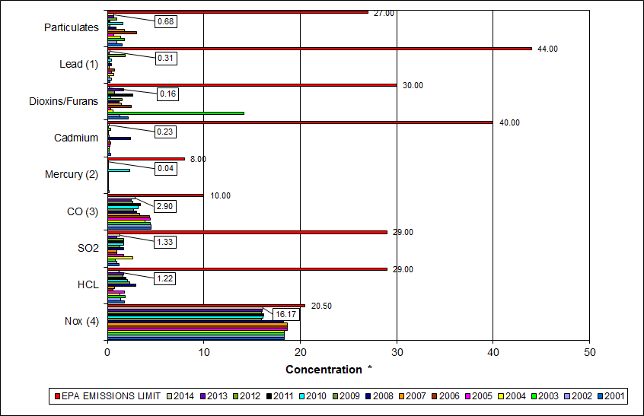

|  |
| --- |
| Note (1): Lead emissions have been decreased by a factor of 10 for trending purposes |
| Note (2): Mercury emissions have been decreased by a factor of 100 for trending purposes |
| Note (3): CO emissions have been decreased by a factor of 10 for trending purposes |
| Note (4): NOx emissions have been decreased by a factor of 10 for trending purposes |

Table 10: Stack Test Results through 2014

|  |  |  |  |  |  |  |  |  |  |  |  |
| --- | --- | --- | --- | --- | --- | --- | --- | --- | --- | --- | --- |
|  |  | **NOx(4)** | **HCL** | **SO2** | **CO(3)** | **Mercury(2)** | **Cadmium** | **Dioxins/Furans** | **Lead(1)** | **Particulates** | **P.M. 2.5** |
|  |  | **(ppmdv)** | **(ppmdv)** | **(ppmdv)** | **(ppmdv)** | **(ug/dscm)** | **(ug/dscm)** | **(ng/dscm)** | **(ug/dscm)** | **(mg/dscm)** | **(gr/dscf)** |
| **2004** | Boiler 1 | 184 | 1.55 | 6 | 38 | 0.35 | 0.21 |  | 2.57 | 0.965 | -- |
| Boiler 2 | 181 | 1.23 | 1 | 49 | 1.56 | 0.247 | 0.578 | 13.0 | 1.80 | -- |
| Boiler 3 | 185 | 1.16 | 1 | 31 | 1.96 | 0.144 |  | 3.46 | 1.41 | -- |
| **AVERAGE** | **183.33** | **1.31** | **2.67** | **39.33** | **1.29** | **0.20** | **0.58** | **6.34** | **1.39** | **--** |
|  |  |  |  |  |  |  |  |  |  |  |  |
| **2005** | Boiler 1 | 187 | 1.86 | 2 | 47 | 0.4 | 0.40 | 0.382 | 6.8 | 0.5 | -- |
| Boiler 2 | 186 | 1.83 | 1 | 48 | 0.4 | 0.2 |  | 4.9 | 0.8 | -- |
| Boiler 3 | 188 | 1.68 | 2 | 39 | 0.4 | 0.2 |  | 1.9 | 0.7 | -- |
| **AVERAGE** | **187.00** | **1.79** | **1.67** | **44.67** | **0.40** | **0.27** | **0.38** | **4.53** | **0.67** | **--** |
|  |  |  |  |  |  |  |  |  |  |  |  |
| **2006** | Boiler 1 | 187 | 0.85 | 1 | 43 | 0.38 | 0.4 |  | 7.79 | 4.84 | -- |
| Boiler 2 | 185 | 0.483 | 1 | 47 | 0.4 | 0.19 |  | 2.51 | 2.15 | -- |
| Boiler 3 | 189 | 0.529 | 1 | 42 | 0.4 | 0.57 | 2.48 | 12.4 | 2 | -- |
| **AVERAGE** | **187.0** | **0.62** | **1.00** | **44.00** | **0.39** | **0.39** | **2.48** | **7.57** | **3.00** | **--** |
|  |  |  |  |  |  |  |  |  |  |  |  |
| **2007** | Boiler 1 | 187 | 0.82 | 1 | 31 | 0.38 | 0.25 |  | 2.31 | 2.03 | -- |
| Boiler 2 | 185 | 0.68 | 1 | 36 | 0.39 | 0.19 | 1.42 | 2.12 | 2.04 | -- |
| Boiler 3 | 189 | 0.84 | 1 | 34 | 0.59 | 0.16 |  | 1.55 | 1.33 | -- |
| **AVERAGE** | **187.0** | **0.78** | **1.00** | **33.67** | **0.46** | **0.20** | **1.42** | **1.99** | **1.80** | **--** |
|  |  |  |  |  |  |  |  |  |  |  |  |
| **2008** | Boiler 1 | 181 | 2.96 | 2 | 37 | 0.45 | 6.60 | 1.25 | 9.4 | 1.46 | -- |
| Boiler 2 | 182 | 3.52 | 2 | 30 | 0.42 | 0.50 |  | 2.6 | 0.82 | -- |
| Boiler 3 | 186 | 2.43 | 1 | 24 | 1.03 | 0.16 |  | 0.23 | 0.48 | -- |
| **AVERAGE** | **183.0** | **3.0** | **1.67** | **30.3** | **0.63** | **2.4** | **1.25** | **4.1** | **0.9** | **--** |
|  |  |  |  |  |  |  |  |  |  |  |  |
| **2009** | Boiler 1 | 159 | 1.40 | 2 | 28 | 0.184 | 0.191 |  | 2.260 | 0.483 | -- |
| Boiler 2 | 158 | 2.12 | 1 | 25 | 0.271 | 0.143 |  | 0.894 | 0.068 | -- |
| Boiler 3 | 163 | 3.53 | 1 | 29 | 0.198 | 0.256 | 1.54 | 3.030 | 0.155 | -- |
| **AVERAGE** | **160** | **2.35** | **1.33** | **27.33** | **0.22** | **0.20** | **1.54** | **2.061** | **0.235** | **--** |
|  |  |  |  |  |  |  |  |  |  |  |  |
| **2010** | Boiler 1 | 159 | 2.69 | 1 | 29 | 5.76 | 0.120 |  | 1.33 | 3.690 | 0.00410 |
| Boiler 2 | 158 | 0.67 | 1 | 28 | 29.50 | 0.032 | 0.35 | 3.00 | 0.914 | 0.00630 |
| Boiler 3 | 168 | 2.85 | 3 | 38 | 34.70 | 0.241 |  | 8.71 | 0.336 | 0.00990 |
| **AVERAGE** | **161.7** | **2.07** | **1.67** | **31.67** | **23.32** | **0.13** | **0.35** | **4.347** | **1.647** | **0.007** |
|  |  |  |  |  |  |  |  |  |  |  |  |
| **2011** | Boiler 1 | 167 | 2.15 | 2 | 28 | 0.36 | 0.140 | 2.67 | 1.72 | 0.130 | 0.00570 |
| Boiler 2 | 159 | 1.14 | 1 | 38 | 0.44 | 0.140 |  | 1.46 | 0.350 | 0.00690 |
| Boiler 3 | 161 | 2.40 | 2 | 37 | 0.36 | 0.110 |  | 1.47 | 0.350 | 0.00170 |
| **AVERAGE** | **162.3** | **1.90** | **1.67** | **34.33** | **0.39** | **0.13** | **2.67** | **1.550** | **0.277** | **0.005** |
|  |  |  |  |  |  |  |  |  |  |  |  |
| **2012** | Boiler 1 | 163 | 1.14 | 2 | 23 | 0.30 | 0.310 |  | 1.34 | 0.640 | 0.00932 |
| Boiler 2 | 156 | 2.02 | 2 | 29 | 0.34 | 0.250 | **0.75** | 6.52 | 1.280 | 0.00782 |
| Boiler 3 | 161 | 1.66 | 1 | 27 | 0.37 | 0.590 |  | 47.80 | 1.020 | 0.00679 |
| **AVERAGE** | **160.0** | **1.61** | **1.67** | **26.33** | **0.34** | **0.38** | **0.75** | **18.553** | **0.980** | **0.008** |
|  |  |  |  |  |  |  |  |  |  |  |  |
| **2013** | Boiler 1 | 164 | 1.48 | 1 | 28 | 0.36 | 0.134 |  | 1.45 | 0.637 | 0.00637 |
| Boiler 2 | 158 | 1.98 | 1 | 25 | 0.37 | 0.112 | 1.66 | 1.05 | 0.737 | 0.00475 |
| Boiler 3 | 159 | 1.52 | 1 | 22 | 0.42 | 0.137 |  | 3.03 | 0.733 | 0.00471 |
| **AVERAGE** | **160.3** | **1.66** | **1.00** | **25.00** | **0.38** | **0.13** | **1.66** | **1.843** | **0.702** | **0.005** |
|  |  |  |  |  |  |  |  |  |  |  |  |
| **2014** | Boiler 1 | 167 | 1.13 | 2 | 35 | 0.33 | 0.270 | 0.16 | 3.82 | 0.282 | 0.00337 |
| Boiler 2 | 157 | 1.02 | 1 | 35 | 0.35 | 0.183 |  | 2.52 | 1.240 | 0.00415 |
| Boiler 3 | 161 | 1.50 | 1 | 17 | 0.49 | 0.228 |  | 2.85 | 0.520 | 0.00425 |
| **AVERAGE** | **161.7** | **1.22** | **1.33** | **29.00** | **0.39** | **0.23** | **0.16** | **3.063** | **0.681** | **0.004** |
|  |  |  |  |  |  |  |  |  |  |  |  |
|  | **EPA EMISSIONS LIMIT** | **205** | **29** | **29** | **100** | **80** | **40** | **30** | **440** | **27** | **--** |
| **Percent of Limit for 2014** | **78.9%** | **4.2%** | **4.6%** | **29.0%** | **0.5%** | **0.6%** | **0.5%** | **0.7%** | **2.5%** | **--** |

## Ash System Compliance

The dolomitic lime feed rate is adjusted periodically in order to maintain a desired ash pH level in the range of 8.0 to 11.0. Since initial startup, the feed rate has varied from between 4 to 9 lbs per ton. Ash Toxicity (TCLP) tests were performed for field samples collected over a seven (7) day period in February 2014, and results indicate that the average pH during testing was 10.3. Results from the TCLP testing conducted in February 2014 are depicted in Table 11 and Chart 16 below.

Table 11: Comparison of Statistical Results and Regulatory Thresholds for Metal Analytes

|  |  |  |  |  |  |
| --- | --- | --- | --- | --- | --- |
| **Metals** | **90% Upper Confidence**  **(February 2014)** | **90% Upper Confidence**  **(November 2013)** | **Regulatory Threshold (mg/L)** | **% of Threshold (February 2014)** | **% of Threshold**  **(November 2013)** |
| **Arsenic** | 0.250 | 0.250 | 5.0 | 5.00% | 5.00% |
| **Barium** | 0.920 | 1.050 | 100.0 | 0.92% | 1.05% |
| **Cadmium** | 0.050 | 0.082 | 1.0 | 5.00% | 8.20% |
| **Chromium** | 0.250 | 0.250 | 5.0 | 5.00% | 5.00% |
| **Lead** | 0.250 | 0.300 | 5.0 | 5.00% | 6.00% |
| **Mercury** | 0.00024 | 0.0003 | 0.2 | 0.12% | 0.15% |
| **Selenium** | 0.050 | 0.050 | 1.0 | 5.00% | 5.00% |
| **Silver** | 0.250 | 0.250 | 5.0 | 5.00% | 5.00% |

Chart 16: Ash Toxicity Characteristic Leaching Procedure (TCLP) Results

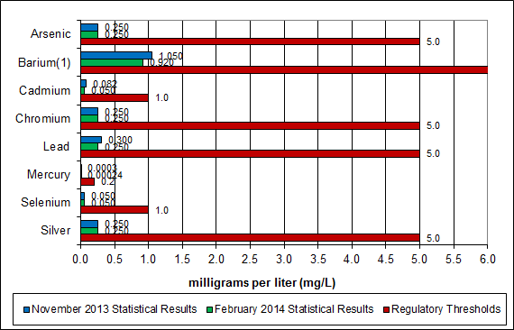

**Note: The regulatory threshold for Barium is 100 mg/L**

CAAI also samples ash monthly in-house, and documents pH reading to adjust dolomitic lime feed rate. The results for the ash pH tests are found below in Chart 17 where each quarter is represented by the average of the respective monthly readings. During Q4FY14, the average ash pH for in-house tests was 10.6.

Chart 17: Quarterly Ash Test Results

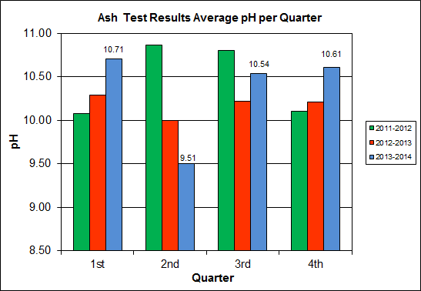

APPENDIX A  
FACILITY CEMS DATA

Table 12: Unit #1 Monthly Summary for Reportable Emissions Data

|  |  |  |  |  |  |  |  |  |  |  |
| --- | --- | --- | --- | --- | --- | --- | --- | --- | --- | --- |
| **Group#-Channel#** | | **G8-C35** | **G8-C28** | **G8-C8** | **G8-C4** | **G8-C12** | **G8-C34** | **G8-C37** | **G8-C40** | **G8-C39** |
| **Long Descrip.** | | **U-1 Steam** | **U-1 Econ** | **U-1 Stack** | **U-1 Stack** | **U-1 Stack** | **U-1 Opaci** | **U-1 FF In** | **U-1 Carbo** | **U-1 Lime** |
| **Short Descrip.** | | **SteamFl** | **SO2ec** | **SO2sc** | **COsc** | **NOxsc** | **Opacity** | **FF InTemp** | **CarbInj** | **LimeFlow** |
| **Units** | | **K#/Hr** | **ppmc** | **ppm** | **ppmc** | **ppmc** | **%** | **deg F** | **#/hr** | **gpm** |
| **Range** | | **0-100** | **0-2000** | **0-500** | **0-4000** | **0-1000** | **0-100** | **100-500** | **0-50** | **0-20** |
| Apr-14 | AVG | 85.0 | 35.0 | 2.0 | 35.0 | 169.0 | 0.6 | 302.0 | 16.3 | 3.0 |
| Max | 88.0 | 46.0 | 4.0 | 43.0 | 187.0 | 1.5 | 303.0 | 17.0 | 3.3 |
| Min | 80.1 | 18.0 | 0.0 | 29.0 | 164.0 | 0.2 | 301.0 | 16.1 | 2.4 |
| May-14 | AVG | 84.0 | 32.0 | 1.0 | 42.0 | 168.0 | 0.9 | 302.0 | 16.3 | 3.0 |
| Max | 89.1 | 51.0 | 4.0 | 251.0 | 184.0 | 2.9 | 303.0 | 16.7 | 3.3 |
| Min | 70.6 | 14.0 | 0.0 | 26.0 | 160.0 | 0.1 | 300.0 | 16.1 | 2.8 |
| Jun-14 | AVG | 84.1 | 31.0 | 1.0 | 34.0 | 167.0 | 0.5 | 302.0 | 16.6 | 3.0 |
| Max | 87.0 | 53.0 | 4.0 | 41.0 | 182.0 | 0.9 | 304.0 | 19.5 | 3.2 |
| Min | 79.2 | 23.0 | 0.0 | 28.0 | 161.0 | 0.2 | 301.0 | 16.2 | 2.7 |
| **Quarter Average** | | 84.4 | 32.7 | 1.3 | 37.0 | 168.0 | 0.7 | 302.0 | 16.4 | 3.0 |
| **Quarter Max Value** | | 89.1 | 53.0 | 4.0 | 251.0 | 187.0 | 2.9 | 304.0 | 19.5 | 3.3 |
| **Quarter Min Value** | | 70.6 | 14.0 | 0.0 | 26.0 | 160.0 | 0.1 | 300.0 | 16.1 | 2.4 |
| **Limits:** | | NA | NA | 29 | 100 | 205 | 10 | 320 | 16(a) |  |

(a) Carbon flow limit is a minimum value

* Note: The data reported herein represent 24 hour average data for all parameters. Emissions excursions that are measured on shorter time intervals (ie., 4-hour block averages for CO) do not correlate with the 24 hour average data reported above.

Table 13: Unit #2 Monthly Summary for Reportable Emissions Data

|  |  |  |  |  |  |  |  |  |  |  |
| --- | --- | --- | --- | --- | --- | --- | --- | --- | --- | --- |
| **Group#-Channel#** | | **G8-C35** | **G8-C28** | **G8-C8** | **G8-C4** | **G8-C12** | **G8-C34** | **G8-C37** | **G8-C40** | **G8-C39** |
| **Long Descrip.** | | **U-2 Steam** | **U-2 Econ** | **U-2 Stack** | **U-2 Stack** | **U-2 Stack** | **U-2 Opaci** | **U-2 FF In** | **U-2 Carbo** | **U-2 Lime** |
| **Short Descrip.** | | **SteamFl** | **SO2ec** | **SO2sc** | **COsc** | **NOxsc** | **Opacity** | **FF InTemp** | **CarbInj** | **LimeFlow** |
| **Units** | | **K#/Hr** | **ppmc** | **ppm** | **ppmc** | **ppmc** | **%** | **deg F** | **#/hr** | **gpm** |
| **Range** | | **0-100** | **0-2000** | **0-500** | **0-4000** | **0-1000** | **0-100** | **100-500** | **0-50** | **0-20** |
| Apr-14 | AVG | 90.4 | 54.0 | 1.0 | 36.0 | 161.0 | 0.3 | 297.0 | 16.3 | 2.9 |
| Max | 93.3 | 72.0 | 3.0 | 45.0 | 179.0 | 1.7 | 297.0 | 17.2 | 3.2 |
| Min | 83.7 | 43.0 | 0.0 | 27.0 | 151.0 | 0.0 | 295.0 | 16.0 | 2.2 |
| May-14 | AVG | 89.3 | 42.0 | 0.0 | 40.0 | 162.0 | 0.0 | 297.0 | 16.3 | 2.9 |
| Max | 92.3 | 59.0 | 2.0 | 49.0 | 177.0 | 0.3 | 298.0 | 17.7 | 3.0 |
| Min | 71.7 | 29.0 | 0.0 | 22.0 | 158.0 | 0.0 | 297.0 | 16.0 | 2.7 |
| Jun-14 | AVG | 85.7 | 34.0 | 0.0 | 35.0 | 159.0 | 0.0 | 297.0 | 16.2 | 2.8 |
| Max | 91.1 | 50.0 | 2.0 | 40.0 | 165.0 | 0.2 | 298.0 | 16.3 | 3.0 |
| Min | 78.1 | 25.0 | 0.0 | 29.0 | 155.0 | 0.0 | 296.0 | 16.0 | 2.7 |
| **Quarter Average** | | 88.5 | 43.3 | 0.3 | 37.0 | 160.7 | 0.1 | 297.0 | 16.3 | 2.9 |
| **Quarter Max Value** | | 93.3 | 72.0 | 3.0 | 49.0 | 179.0 | 1.7 | 298.0 | 17.7 | 3.2 |
| **Quarter Min Value** | | 71.7 | 25.0 | 0.0 | 22.0 | 151.0 | 0.0 | 295.0 | 16.0 | 2.2 |
| **Limits:** | | NA | NA | 29 | 100 | 205 | 10 | 320 | 17(a) |  |

(a) Carbon flow limit is a minimum value

* Note: The data reported herein represent 24 hour average data for all parameters. Emissions excursions that are measured on shorter time intervals (ie., 4-hour block averages for CO) do not correlate with the 24 hour average data reported above.

Table 14: Unit #3 Monthly Summary for Reportable Emissions Data

|  |  |  |  |  |  |  |  |  |  |  |
| --- | --- | --- | --- | --- | --- | --- | --- | --- | --- | --- |
| **Group#-Channel#** | | **G8-C35** | **G8-C28** | **G8-C8** | **G8-C4** | **G8-C12** | **G8-C34** | **G8-C37** | **G8-C40** | **G8-C39** |
| **Long Descrip.** | | **U-3 Steam** | **U-3 Econ** | **U-3 Stack** | **U-3 Stack** | **U-3 Stack** | **U-3 Opaci** | **U-3 FF In** | **U-3 Carbo** | **U-3 Lime** |
| **Short Descrip.** | | **SteamFl** | **SO2ec** | **SO2sc** | **COsc** | **NOxsc** | **Opacity** | **FF InTemp** | **CarbInj** | **LimeFlow** |
| **Units** | | **K#/Hr** | **ppmc** | **ppm** | **ppmc** | **ppmc** | **%** | **deg F** | **#/hr** | **gpm** |
| **Range** | | **0-100** | **0-2000** | **0-500** | **0-4000** | **0-1000** | **0-100** | **100-500** | **0-50** | **0-20** |
| Apr-14 | AVG | 91.7 | 48.0 | 1.0 | 26.0 | 162.0 | 0.0 | 303.0 | 16.1 | 3.2 |
| Max | 93.6 | 59.0 | 3.0 | 34.0 | 179.0 | 0.3 | 303.0 | 16.3 | 3.8 |
| Min | 83.6 | 36.0 | 0.0 | 19.0 | 158.0 | 0.0 | 302.0 | 16.0 | 2.4 |
| May-14 | AVG | 89.0 | 35.0 | 1.0 | 35.0 | 162.0 | 0.0 | 302.0 | 16.2 | 3.1 |
| Max | 92.3 | 55.0 | 4.0 | 91.0 | 171.0 | 0.3 | 304.0 | 16.6 | 3.5 |
| Min | 71.6 | 25.0 | 0.0 | 17.0 | 159.0 | 0.0 | 301.0 | 16.1 | 2.9 |
| Jun-14 | AVG | 88.7 | 33.0 | 1.0 | 29.0 | 160.0 | 0.0 | 303.0 | 16.2 | 3.1 |
| Max | 92.2 | 55.0 | 2.0 | 39.0 | 167.0 | 0.0 | 304.0 | 16.6 | 3.2 |
| Min | 84.0 | 23.0 | 0.0 | 20.0 | 158.0 | 0.0 | 302.0 | 16.0 | 2.9 |
| **Quarter Average** | | 89.8 | 38.7 | 1.0 | 30.0 | 161.3 | 0.0 | 302.7 | 16.2 | 3.1 |
| **Quarter Max Value** | | 93.6 | 59.0 | 4.0 | 91.0 | 179.0 | 0.3 | 304.0 | 16.6 | 3.8 |
| **Quarter Min Value** | | 71.6 | 23.0 | 0.0 | 17.0 | 158.0 | 0.0 | 301.0 | 16.0 | 2.4 |
| **Limits:** | | NA | NA | 29 | 100 | 205 | 10 | 320 | 16(a) |  |

(a) Carbon flow limit is a minimum value

* Note: The data reported herein represent 24 hour average data for all parameters. Emissions excursions that are measured on shorter time intervals (ie., 4-hour block averages for CO) do not correlate with the 24 hour average data reported above.

APPENDIX B  
SITE PHOTOS – May 2014

|  |  |
| --- | --- |
| C:\Users\kperrin\Desktop\May 2014\P1000403.JPG  Figure 1: Fire hose not mounted properly at SDA No. 3 Penthouse Access Door - New Deficiency | C:\Users\kperrin\Desktop\May 2014\P1000412.JPG  Figure 2: Personal Protective Equipment locker in APC MCC Electrical Room Empty – New Deficiency |
| C:\Users\kperrin\Desktop\May 2014\P1000429.JPG  Figure 3: Unused tarp laying over cable trays at Slaker Room No. 1 | C:\Users\kperrin\Desktop\May 2014\P1000449.JPG  Figure 4: Pothole at Tipping Floor Exit Driveway |
| C:\Users\kperrin\Desktop\May 2014\P1000448.JPG  Figure 5: Concrete to roadway drain at truck entrance damaged – exposing reinforcing bar | E:\Alexandria Arlington\Alexandria Arlington - Q4FY14\May 2014\P1000401.JPG  Figure 6: Cooling Tower Deck from SDA Penthouse |
| E:\Alexandria Arlington\Alexandria Arlington - Q4FY14\May 2014\P1000405.JPG  Figure 7: Deaerator | E:\Alexandria Arlington\Alexandria Arlington - Q4FY14\May 2014\P1000406.JPG  Figure 8: Auxiliary Burner |
| E:\Alexandria Arlington\Alexandria Arlington - Q4FY14\May 2014\P1000407.JPG  Figure 9: Turbine Generator Enclosure – New Paint Job on Turbine Generator No. 1 | E:\Alexandria Arlington\Alexandria Arlington - Q4FY14\May 2014\P1000410.JPG  Figure 10: New Screw Conveyor Troughs |
| E:\Alexandria Arlington\Alexandria Arlington - Q4FY14\May 2014\P1000411.JPG  Figure 11: Dolomitic Lime Silo | E:\Alexandria Arlington\Alexandria Arlington - Q4FY14\May 2014\P1000417.JPG  Figure 12: SDA No. 2 Double Dump Valve |
| E:\Alexandria Arlington\Alexandria Arlington - Q4FY14\May 2014\P1000427.JPG  Figure 13: Lime Slaker Enclosure | E:\Alexandria Arlington\Alexandria Arlington - Q4FY14\May 2014\P1000430.JPG  Figure 14: Lime Slurry Pump Enclosure |
| E:\Alexandria Arlington\Alexandria Arlington - Q4FY14\May 2014\P1000433.JPG  Figure 15: Ash Load-Out Area | E:\Alexandria Arlington\Alexandria Arlington - Q4FY14\May 2014\P1000435.JPG  Figure 16: Ammonia Storage Tank |
| E:\Alexandria Arlington\Alexandria Arlington - Q4FY14\May 2014\P1000440.JPG  Figure 17: New Loading Dock – Construction complete with the exception of permanent safety railings | E:\Alexandria Arlington\Alexandria Arlington - Q4FY14\May 2014\P1000441.JPG  Figure 18: New Loading Dock – Alternate View |
| E:\Alexandria Arlington\Alexandria Arlington - Q4FY14\May 2014\P1000442.JPG  Figure 19: New Tipping Floor Signs – (Deficiency Item No. 4 – Complete) | E:\Alexandria Arlington\Alexandria Arlington - Q4FY14\May 2014\P1000438.JPG  Figure 20: Metal Roll-Off |
| E:\Alexandria Arlington\Alexandria Arlington - Q4FY14\May 2014\P1000444.JPG  Figure 21: Scale House and Scale Area | E:\Alexandria Arlington\Alexandria Arlington - Q4FY14\May 2014\P1000446.JPG  Figure 22: Citizen’s Drop-off Roll-off |
| E:\Alexandria Arlington\Alexandria Arlington - Q4FY14\May 2014\P1000452.JPG  Figure 23: Main Vibratory Ash Conveyor | E:\Alexandria Arlington\Alexandria Arlington - Q4FY14\May 2014\P1000454.JPG  Figure 24: Steam Coil Air Heater |